**Experiment No: 06**

**Experiment name:**

Write a program for deletion from a linked list.

**Objectives:**

To study and write program that how to delete from a linked list.

**Pseudo code :**

|  |
| --- |
| #include<stdio.h>  #include<stdlib.h>  struct student  {  int value;  struct student *next;  };  int main()  {  typedef struct student node;  node *h=0,*PTR,*q=0,*ptr,*PTR1;  int v,delete_value;  printf("Press -99 for break.\n");  printf("Enter values:\n");  for(;;)  {  scanf("%d",&v);  if(v==-99)  break;  else  {  PTR=(node*)malloc(sizeof(node));  if(h==0)  {  PTR->value=v;  PTR->next=NULL;  h=PTR;  q=PTR;  }  else  {  PTR->value=v;  PTR->next=NULL;  q->next=PTR;  q=PTR;  }  }  }  printf("The value is:\n");  PTR=h;  ptr=h;  while(PTR!=NULL)  {  printf("%d\n",PTR->value);  PTR=PTR->next;  }  printf("\n1 for delete first\n");  printf("2 for delete last\n");  printf("3 for delete middle\n");  int t;  for(;;)  {  scanf("%d",&t);  if(t==0)  break;  if(t==1)  {  printf("The value is:\n");  ptr=ptr->next;  PTR=ptr;  while(PTR!=NULL)  {  printf("%d\n",PTR->value);  PTR=PTR->next;  }  }  else if(t==2)  {  printf("The value is:\n");  PTR=h;  while(PTR->next!=NULL)  {  PTR1=PTR;  PTR=PTR->next;  }  PTR1->next=NULL;  PTR=h;  while(PTR!=NULL)  {  printf("%d\n",PTR->value);  PTR=PTR->next;  }  }  else if(t==3)  {  printf("Enter the delete value:");  scanf("%d",&delete_value);  printf("The value is:\n");  PTR=h;  while(PTR->value!=delete_value)  {  PTR1=PTR;  PTR=PTR->next;  }  PTR1->next=PTR->next;  PTR=h;  while(PTR!=NULL)  {  printf("%d\n",PTR->value);  PTR=PTR->next;  }  }  }  } |

**Result:**

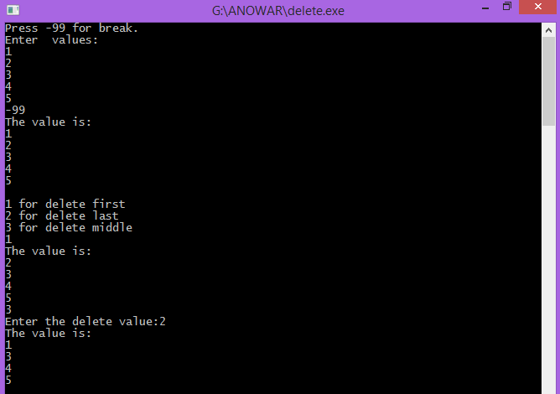

Discussion:

From study about traverse, delete first,middle ,and last element from a linked list ,I will know how can I do it . I write an algorithm ,then I write those program according to it. Firstly, I face some problems to solve this problems.Then our honorable teacher help us to solve this problems.